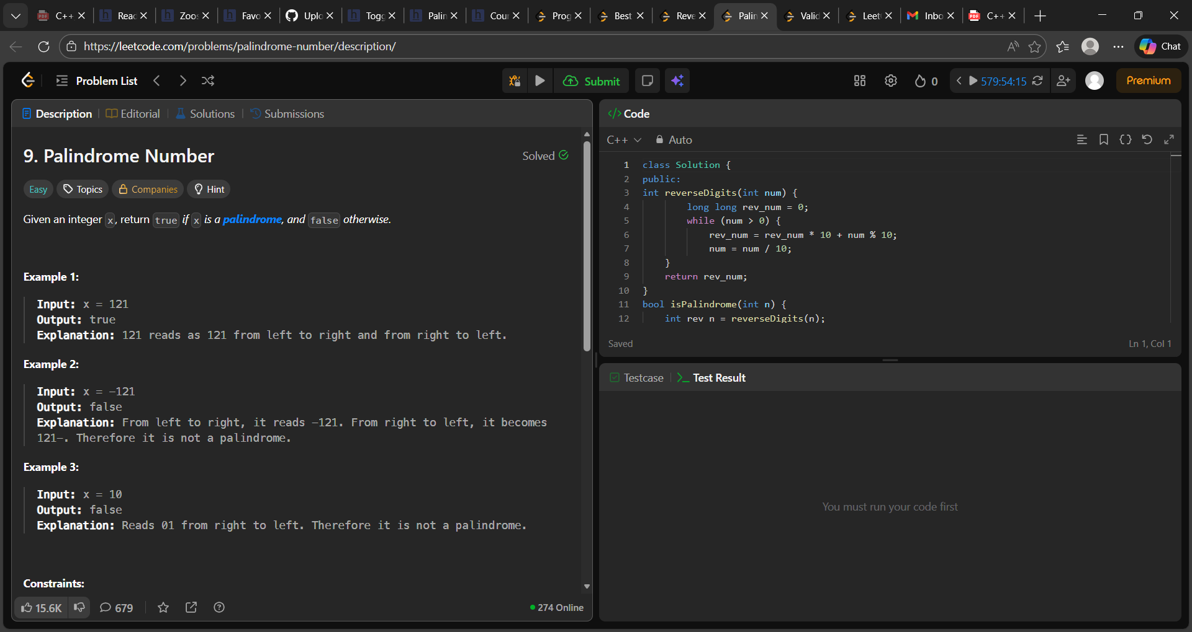

class Solution {
public:
int reverseDigits(int num) {
long long rev_num = 0;
while (num > 0) {
rev_num = rev_num * 10 + num % 10;
num = num / 10;
}
return rev_num;
}
bool isPalindrome(int n) {
int rev_n = reverseDigits(n);
return (rev_n == n);
}
};

